Programs using Matplotlib

1. Draw a line in a diagram from position (1, 3) to (2, 10) then to (6, 12) and finally to position (18, 20). (Mark each point with beautiful green colour and set the line colour to red and line style dotted)  
2. Draw a plot for the following data:

|  |  |
| --- | --- |
| Temperature in degrees Celsius | Sales |
| 12 | 100 |
| 14 | 200 |
| 16 | 250 |
| 18 | 400 |
| 20 | 300 |
| 22 | 450 |
| 24 | 500 |

3. Write a Python program to draw a line using given axis values taken from a text file, with suitable  
label in the x axis, y axis and a title.

4. Write a Python program to plot two or more lines on same plot with suitable legends of each line.

5. Write a Python program to create multiple plots.

6. Consider the following data.

|  |  |  |  |  |  |  |
| --- | --- | --- | --- | --- | --- | --- |
| Programming languages: | Java | Python | PHP | JavaScript | C# | C++ |
| Popularity | 22.2 | 17.6 | 8.8 | 8 | 77 | 6.7 |

1. Write a Python program to display a bar chart of the programming languages’ popular)
2. Write a Python program to display a horizontal bar chart of the popularity of programming Languages (Give Red colour to the bar chart).
3. Write a Python program to display a bar chart of with respect to the popularity of programming Languages.  
   Use different colour for each bar.

7. Write a Python program to create bar plot of scores by group and gender. Use multiple X values on the same chart for men and women.

Sample Data:  
Means (men) = (22, 30, 35, 35, 26)  
Means (women) = (25, 32, 30, 35, 29)

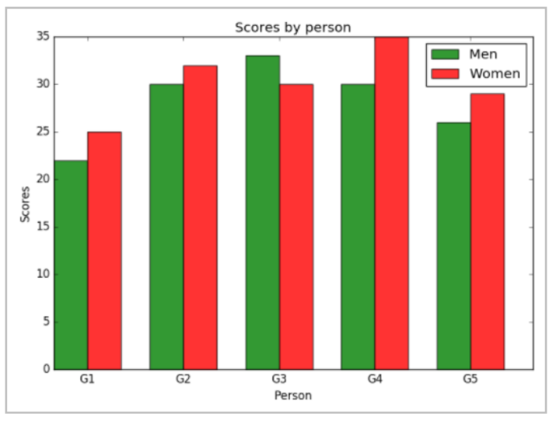

8. Write a Python programming to create a pie chart of the popularity of programming Languages.

|  |  |  |  |  |  |  |
| --- | --- | --- | --- | --- | --- | --- |
| Programming languages: | Java | Python | PHP | JavaScript | C# | C++ |
| Popularity | 22.2 | 17.6 | 8.8 | 8 | 77 | 6.7 |

9. Write a Python programming to create a pie chart of gold medal achievements of five most  
successful countries in 2016 Summer Olympics. Read the data from a csv file.  
Sample data:  
medal.csvcountry,gold_medal  
Unityited States,46  
Great Britain,27  
China,26  
Russia,19  
Germany,17

10. Write a Python program to draw a scatter plot comparing two subject marks of Mathematics and  
Science. Use marks of 10 students.  
Sample data:  
Test Data:  
math_marks = [88, 92, 80, 89, 100, 80, 60, 100, 80, 34]  
science_marks = [35, 79, 79, 48, 100, 88, 32, 45, 20, 30]  
marks_range = [10, 20, 30, 40, 50, 60, 70, 80, 90, 100]

